|  |  |
| --- | --- |
| **Ex. No. 2** | **Working with HTML5 forms and media elements** |
| **Date of Exercise** | 17/12/2022 |

**Aim**

To build a HTML5 website that consists of a web based form and media elements

**Description**

* video: To place a video in our webpage.
  + - attributes: controls: that displays the controls
      * width, height: width & height of video
      * sub elements: source: source to the video is specified
* audio: To place an audio file in our webpage
  + attributes: Control, autoplay, loops.
  + subelement: source
* fieldset: to make the elements to a collection/groups for clear representation.
* iframe: to embed another HTML document to current html
  + attributes: src, title, width, height
* form: creates an html form that collects data from the user.
  + attributes: action, method.

Subelements:

* label: To label the input fields [for: specifies to which input field].
* input: attributes: type, size, name, id
  + text: a normal text, single line input field
  + number: a number input field.
  + range: a slider for choosing the range.
  + radio: button for selecting a choice
  + checkbox: checkboxes for selecting. one option. more than
  + date: for picking up a date.
  + +tel: for getting a telephone number.
  + email: for email input.
  + file: for uploading a file to the form
* textarea: a multiline input box attributes, cols, rows.
* select: a combobox for choosing an item from the list. Subelement: option for placing the options to select

**Program**

<!DOCTYPE html>

<html lang="en">

<head>

<meta charset="UTF-8">

<meta http-equiv="X-UA-Compatible" content="IE=edge">

<meta name="viewport" content="width=device-width, initial-scale=1.0">

<title>Document</title>

</head>

<body>

<table align="center">

<tr>

<td><img src="alpha.jpg" alt="alpha_logo.jpg" width="70" height="55"></td>

<td>

<h1>Alpha Company</h1>

</td>

</tr>

</table>

<hr>

<table width="100%">

<tr align="center">

<td width="22%"><a href="https://alpha.com">Commercial Alpha</a></td>

<td width="22%"><a href="https://alpha.org">Organizational Alpha</a></td>

<td width="22%"><a href="https://alpha.in">Indian Alpha</a></td>

<td width="44%">

<form action="" method="get" id="search_form">

<input name="search_string" placeholder="Search here">

</form>

</td>

</tr>

</table>

<hr>

<table width="100%">

<tr>

<td align="center" rowspan="2"><video width="100%" height="80%" controls autoplay><source src="video1.mp4" type="video/mp4" > Your Browser Dosen't Supports the video</video></td>

<td>Established in 1980 by Mr. Kanhaiyalal Agarwal, Alpha Polytechno, as it was known then, benefited from being in middle of the textile hub in India. With PVC being used widely in the industry, Alpha saw an opportunity to change the industry

standard by introducing Polypropylene Tubular Quench (PPTQ) film because of its clarity and strength. With first plant in Mr. Agarwal’s basement in small village called Navsari (about 200 km north of Mumbai), capacity of about 10 MT per

month was installed.<b>(Source: https://alpha.in)</b></td>

</tr>

<tr>

<td align="center"><audio controls autoplay loop>

<source src="audio2.ogg" type="audio/ogg">Your Browser Dosen't Supports the Audio</audio>

</td>

</tr>

</table>

<hr>

<table width="100%">

<tr>

<td>

<fieldset>

<legend>Signup</legend>

<label for="uname"><sup>*</sup>Username:</label>

<input type="text" name="uname" placeholder="Username"><br><br>

<label for="pass"><sup>*</sup>Password:</label>

<input type="text" name="pass" placeholder="Password"><br><br>

<center><a href="my_company_register_page.html"><button>Register</button></a></center>

</fieldset>

</td>

<td align="center">

<h5>Contact Us</h5>

<p>Karunya Institute of Technology and Sciences,<br>Karunya Nagar,<br>Coimbatore-632-xxx. <br>Phone: <a href="tel:987654xxxx">987654xxxx</a> <br>Mail Id: <a href="mailto:alpha@gmail.com">alpha@gamil.com</a></p>

</td>

<td align="center"><iframe src=https://www.google.com/maps/embed?pb=!1m18!1m12!1m3!1d15669.439505653552!2d76.73530697822567!3d10.93616448868134!2m3!1f0!2f0!3f0!3m2!1i1024!2i768!4f13.1!3m3!1m2!1s0x3ba866bd6aaaaaab%3A0xc650b8a75e7b51f0!2sKarunya%20Institute%20of%20Technology%20and%20Sciences%20(Deemed%20University)!5e0!3m2!1sen!2sin!4v1671362012676!5m2!1sen!2sin style="border:0;" allowfullscreen="" loading="lazy" referrerpolicy="no-referrer-when-downgrade"></iframe></td>

</tr>

</table>

</body>

</html>

<!DOCTYPE html>

<html lang="en">

<head>

<meta charset="UTF-8">

<meta http-equiv="X-UA-Compatible" content="IE=edge">

<meta name="viewport" content="width=device-width, initial-scale=1.0">

<title>Alpha Company Registration Webpage</title>

</head>

<body>

<h3>Submit Your Resume</h3>

<form action="submit.php" method="get" autocomplete="on">

<fieldset style="width: fit-content;">

<legend>Personal Details</legend>

<table>

<tr>

<td><label for="fname"><sup>*</sup>First Name:</label></td>

<td><input type="text" name="fname" placeholder="Enter Your First Name" autofocus required></td>

</tr>

<tr>

<td><label for="mname"><sup>*</sup>Middle Name:</label></td>

<td><input type="text" name="mname" placeholder="Enter Your Middle Name" required></td>

</tr>

<tr>

<td><label for="lname"><sup>*</sup>Last Name:</label></td>

<td><input type="text" name="lname" placeholder="Enter Your Last Name" required></td>

</tr>

<tr>

<td><label for="dob">Date of Birth:</label></td>

<td><input type="date" name="dob"></td>

</tr>

<tr>

<td><label for="age"> Age in years:</label></td>

<td><input type="number" min="18" max="30"></td>

</tr>

<tr>

<td><label for="gender">Gender: </label></td>

<td><input type="radio" name="gender">Male

<input type="radio" name="gender">Female</td>

</tr>

</table>

</fieldset>

<input type="range" value="20" name="r1" disabled><label for="r1">20% out of 100%</label>

<fieldset style="width: fit-content;">

<legend>Address Details</legend>

<table>

<tr>

<td><label for="address">Address:</label></td>

<td><textarea name="address" id="" cols="40" rows="3"></textarea></td>

</tr>

<tr>

<td><label for="city/town">City/Town:</label></td>

<td><input type="text" name="city/town"></td>

</tr>

<tr>

<td><label for="state">State:</label></td>

<td><select name="state" id="">

<option value="Tamilnadu">Tamilnadu</option>

<option value="Kerala">Kerala</option>

<option value="Karnataka">Karnataka</option>

<option value="Andhra Pradesh">Andhra Pradesh</option>

</select></td>

</tr>

<tr>

<td><label for="pin_code">Zip code:</label></td>

<td><input type="number" maxlength="6" min="6" placeholder="only 6 numbers"></td>

</tr>

</table>

</fieldset>

<input type="range" value="40" name="r2" disabled><label for="r2">40% out of 100%</label>

<fieldset style="width: fit-content;">

<legend>Contact Information</legend>

<table>

<tr>

<td><label for="telephone">Telephone:</label></td>

<td><input type="tel" name="telephone" placeholder="(044) 999-9999" pattern="[(044)]+[ ]+[0-9]{3}+[0-9]{4}"></td>

</tr>

<tr>

<td><label for="mobile"><sup>*</sup>Mobile:</label></td>

<td><input type="tel" name="mobile" placeholder="(+91) 99999-99999" pattern="[(+91)]+[ ]+[0-9]{5}+-+[0-9]{5},[0-9]{5}+-+[0-9]{5}"></td>

</tr>

<tr>

<td><label for="kmail"><sup>*</sup>Kmail:</label></td>

<td><input type="email" name="kmail" placeholder="Vaild Kmail" pattern="[a-z]+@karunya.edu.in$"></td>

</tr>

<tr>

<td><label for="website">Website:</label></td>

<td><input type="url" name="website" placeholder="Valid URL"></td>

</tr>

</table>

</fieldset>

<input type="range" value="60" name="r3" disabled><label for="r3">60% out of 100%</label>

<fieldset style="width:fit-content;">

<legend>Educational Details</legend>

<table border="1" style="border-collapse: collapse;">

<tr>

<th>Qualification</th>

<th>Board/University</th>

<th>Country</th>

<th>Starting Year</th>

<th>Ending Year</th>

<th>Percentage</th>

</tr>

<tr>

<td><input type="checkbox" name="10th" checked><label for="10th">10th</label></td>

<td><input type="text" name="10th_b/u" placeholder="Board/university" size="15"></td>

<td><select name="10th_c"><option value="india">India</option><option value="pakistan">Pakistan</option><option value="afganistan">Afganistan</option><option value="srilanka">Sri Lanka</option></select></td>

<td><input type="date" name="10th_s"></td>

<td><input type="date" name="10th_e"></td>

<td align="center"><input type="number" min="0" max="100" width="20" name="10th_m" style="width: 50px;"></td>

</tr>

<tr>

<td><input type="checkbox" name="12th" checked><label for="12th">12th</label></td>

<td><input type="text" name="12th_b/u" placeholder="Board/university" size="15"></td>

<td><select name="12th_c"><option value="india">India</option><option value="pakistan">Pakistan</option><option value="afganistan">Afganistan</option><option value="srilanka">Sri Lanka</option></select></td>

<td><input type="date" name="12th_s"></td>

<td><input type="date" name="12th_e"></td>

<td align="center"><input type="number" min="0" max="100" width="20" name="12th_m" style="width: 50px;"></td>

</tr>

<tr>

<td><input type="checkbox" name="b"><label for="b">B.Tech</label></td>

<td><input type="text" name="b_b/u" placeholder="Board/university" size="15"></td>

<td><select name="b_c"><option value="india">India</option><option value="pakistan">Pakistan</option><option value="afganistan">Afganistan</option><option value="srilanka">Sri Lanka</option></select></td>

<td><input type="date" name="b_s"></td>

<td><input type="date" name="b_e"></td>

<td align="center"><input type="number" min="0" max="100" width="20" name="b_m" style="width: 50px;"></td>

</tr>

<tr>

<td><input type="checkbox" name="m"><label for="m">M.Tech</label></td>

<td><input type="text" name="m_b/u" placeholder="Board/university" size="15"></td>

<td><select name="m_c"><option value="india">India</option><option value="pakistan">Pakistan</option><option value="afganistan">Afganistan</option><option value="srilanka">Sri Lanka</option></select></td>

<td><input type="date" name="m_s"></td>

<td><input type="date" name="m_e"></td>

<td align="center"><input type="number" min="0" max="100" width="20" name="m_m" style="width: 50px;"></td>

</tr>

</table>

</fieldset>

<input type="range" value="80" name="r4" disabled><label for="r4">80% out of 100%</label>

<fieldset style="width: fit-content;">

<table>

<tr>

<td>

<p>Attach your resume in .doc or .pdf format</p>

</td>

<td><input type="file" accept="application/pdf,application/vnd.ms-word"></td>

</tr>

<tr>

<td><input type="checkbox" name="confirmation" checked><label for="confirmation">I have Filled all the details</label></td>

</tr>

</table>

</fieldset>

<input type="range" value="100" name="r5" disabled><label for="r5">100% out of 100%</label>

<center><input type="submit"></center>

</form>

</body>

</html>

**Output**

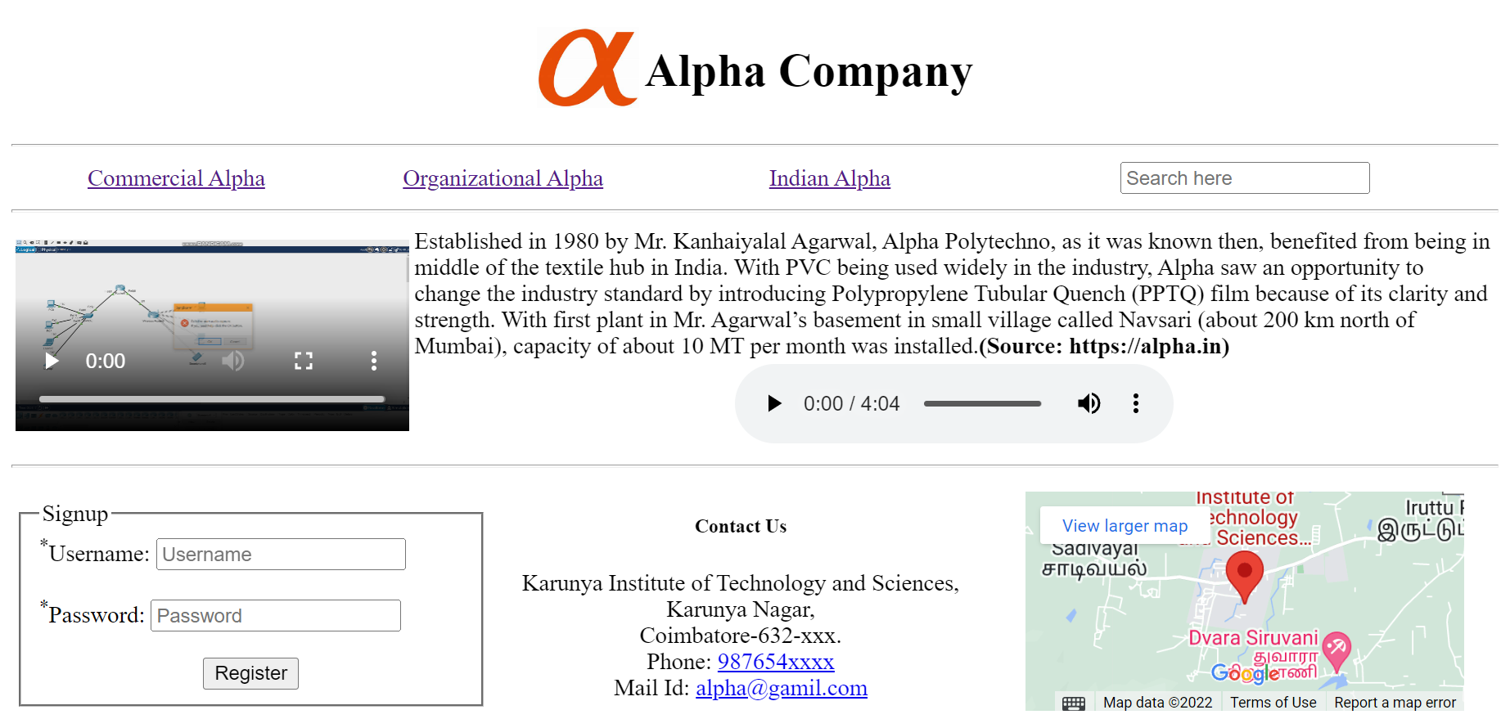

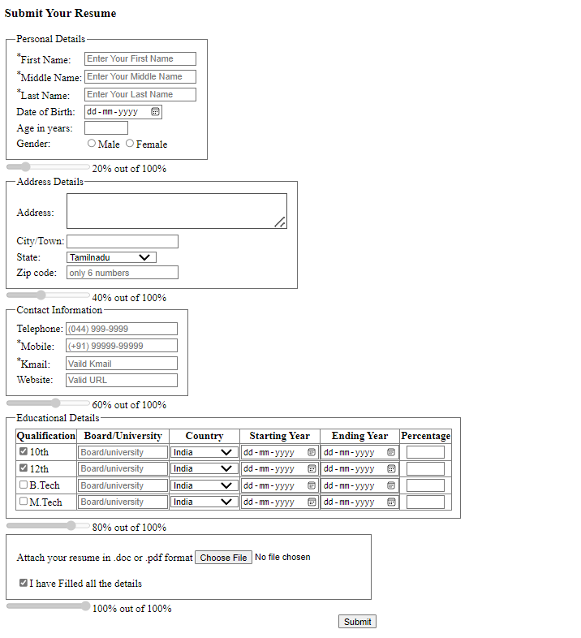

**Result**

The HTML website that consists of media elements and web form has been modelled and the same is been rendered and displayed by the browser successfully.